Name: Shreyash Patil

PRN: 22510039

Batch: T3

ADS assignment 9:- MongoDB and CassandraDB

Using same frontend page for MongoDB and Cassandra DB, backends:-

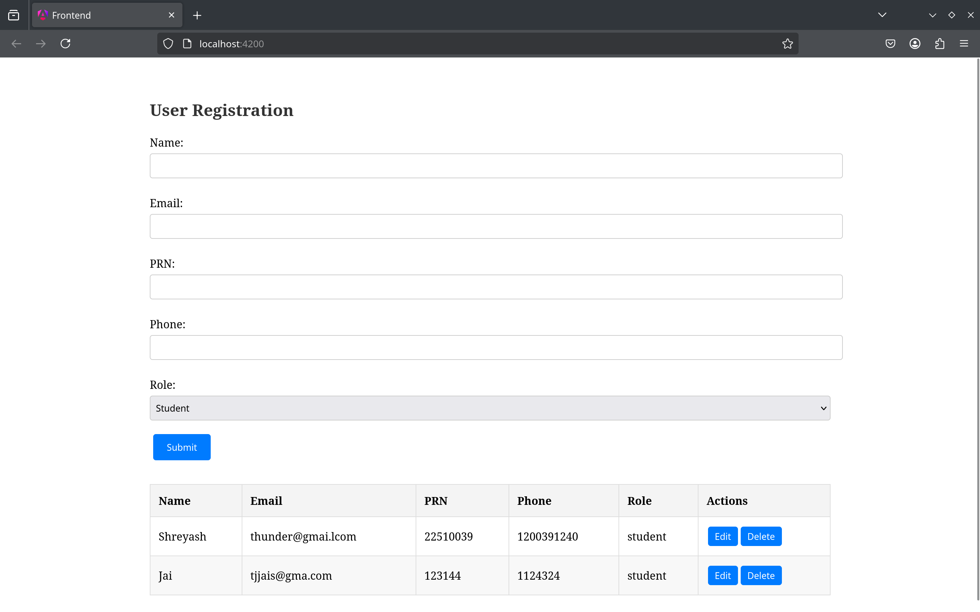

For mongoDB:-

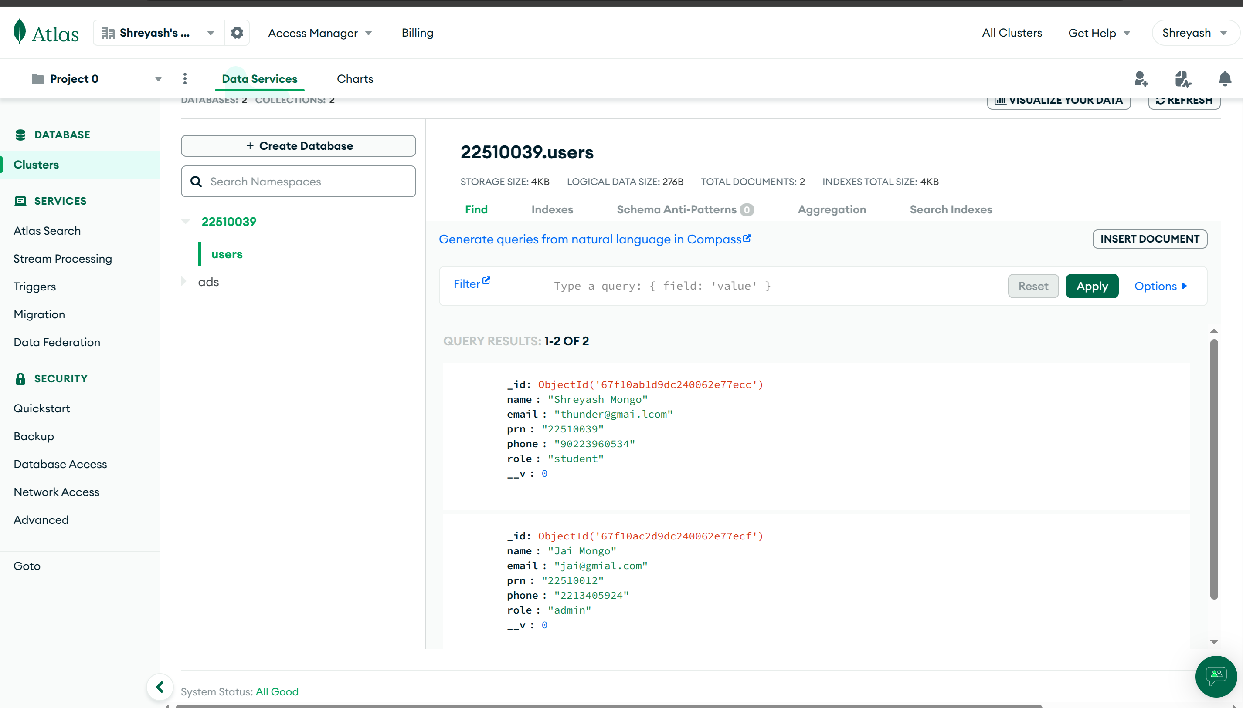

For cassandra DB:

